Spectral coherence: EURUSD and GBPUSD
Method 21 / daily log returns / Welch magnitude-squared coherence / Alpari D1 full available history

Study setup
Logical pair: EURUSD , GBPUSD
Broker symbols: EURUSD_i , GBPUSD_i
Snapshot: 2026-11-03_majors_alpari_D1
Timeframe: D1
Matched return window: 1999-01-05 to 2026-11-02 (UTC bar dates)
Matched return count n: 7202
Dropped unfinished last bar dated 2026-11-03 UTC after a tick-volume check against the prior complete day.
Welch: fs=1.0, nperseg=256, noverlap=128, window=hann, detrend=constant
Headline: gamma^2 nearest f=1/5; also 1/21 and 1/63
Complete matched rows (Excel): EURUSD-GBPUSD_Spectral_D1.xlsx
Complete matched rows (HTML table): EURUSD-GBPUSD_Spectral_D1_data.html

Method carried forward
Magnitude-squared spectral coherence gamma^2(f) measures shared linear power between matched daily log returns of close, ln(close_t / close_t-1), at each frequency f (cycles per day). Quotes are not inverted. Welch settings are frozen: fs=1, nperseg=256, noverlap=128, window=hann, detrend=constant. Headline is gamma^2 at the frequency bin nearest f=1/5 (five-day cycle from the formula sheet). Also reported: gamma^2 nearest f=1/21 and f=1/63, mean gamma^2 over the frequency grid, and phase of the cross-spectrum at the 1/5 bin. Coherence is unsigned (0 to 1); phase carries timing. Same-sample Pearson r is a side check only. This is not causation and not a trading signal.

Results (headline)
gamma^2 near 1/5: 0.343395
bin f (1/5): 0.199219
phase at 1/5 (rad): 0.152792
gamma^2 near 1/21: 0.353928
gamma^2 near 1/63: 0.427611
mean gamma^2: 0.426530
Pearson r: 0.641738

Target-frequency summary
period | target_f | f_bin | gamma2 | phase_rad
5 | 0.2 | 0.19921875 | 0.34339471 | 0.1527924
21 | 0.04761905 | 0.046875 | 0.35392805 | -0.08631441
63 | 0.01587302 | 0.015625 | 0.4276112 | -0.22345058

Conclusion
Headline gamma^2 near f=1/5 for EURUSD and GBPUSD: 0.3434 (bin f=0.199219, phase=0.1528 rad). At ~1/21: 0.3539; at ~1/63: 0.4276. Mean gamma^2 = 0.4265. Pearson r = 0.6417. This is frequency-domain linkage, not a trading signal.

Charts
Daily closes

Daily log returns

Spectral coherence gamma^2(f)
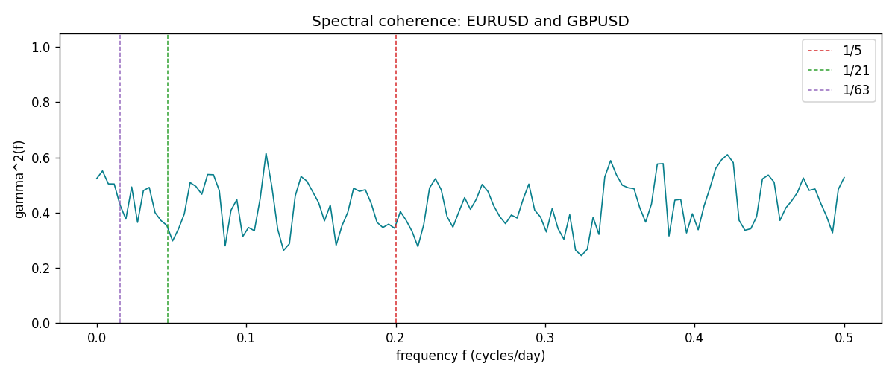

Data report
Matched rows and the coherence sheet are in the sibling Excel workbook named EURUSD-GBPUSD_Spectral_D1.xlsx. Embedding all rows as a Word table is impractical; this file holds column summaries and the first and last 15 matched rows.
Columns: time, EURUSD_open, GBPUSD_open, EURUSD_high, GBPUSD_high, EURUSD_low, GBPUSD_low, EURUSD_close, GBPUSD_close, EURUSD_tick_volume, GBPUSD_tick_volume, EURUSD_spread, GBPUSD_spread, EURUSD_real_volume, GBPUSD_real_volume, EURUSD_log_return, GBPUSD_log_return
Column summaries (matched calculation rows)
column | count | mean | std | min | 25% | 50% | 75% | max
EURUSD_open | 7202 | 1.1812936 | 0.15087968 | 0.8272 | 1.086065 | 1.166145 | 1.293925 | 1.5995
GBPUSD_open | 7202 | 1.5160822 | 0.2182507 | 1.06854 | 1.325005 | 1.51141 | 1.63166 | 2.1066
EURUSD_high | 7202 | 1.1864255 | 0.15147858 | 0.8326 | 1.0901775 | 1.17127 | 1.2992275 | 1.6038
GBPUSD_high | 7202 | 1.5223773 | 0.21881719 | 1.08366 | 1.329795 | 1.51815 | 1.63839 | 2.1161
EURUSD_low | 7202 | 1.1762813 | 0.15020267 | 0.8227 | 1.0819975 | 1.162535 | 1.288315 | 1.5865
GBPUSD_low | 7202 | 1.5097565 | 0.21747799 | 1.03518 | 1.3195075 | 1.503295 | 1.6243825 | 2.0983
EURUSD_close | 7202 | 1.1813323 | 0.15085599 | 0.8267 | 1.0860025 | 1.166105 | 1.2939475 | 1.5997
GBPUSD_close | 7202 | 1.5161468 | 0.21820921 | 1.06879 | 1.325125 | 1.511325 | 1.632095 | 2.1065
EURUSD_tick_volume | 7202 | 102990.53 | 173401.83 | 218 | 9388.25 | 52708 | 99433.75 | 1471626
GBPUSD_tick_volume | 7202 | 94813.509 | 153540.37 | 62 | 9988.5 | 52886.5 | 91789.25 | 1273370
EURUSD_spread | 7202 | 19.400444 | 16.577153 | 0 | 8 | 12 | 30 | 50
GBPUSD_spread | 7202 | 26.974313 | 19.194125 | 0 | 11 | 20 | 50 | 50
EURUSD_real_volume | 7202 | 4.0233049e+10 | 1.6674277e+11 | 0 | 0 | 0 | 0 | 3.6149665e+12
GBPUSD_real_volume | 7202 | 3.5555961e+09 | 8.4432361e+10 | 0 | 0 | 0 | 0 | 2.4038164e+12
EURUSD_log_return | 7202 | -7.71e-06 | 0.00580133 | -0.03123819 | -0.00324586 | 0 | 0.00325471 | 0.03433183
GBPUSD_log_return | 7202 | -2.587e-05 | 0.00564523 | -0.08388241 | -0.00313091 | 3.124e-05 | 0.00317757 | 0.03112653
First 15 matched rows (selected columns)
time | EURUSD_log_return | GBPUSD_log_return
1999-01-05 | -0.0048360507 | -0.0028966287
1999-01-06 | -0.011547966 | -0.00060452184
1999-01-07 | 0.0076280636 | -0.002118709
1999-01-08 | -0.010902799 | -0.0058954193
1999-01-11 | -0.007103287 | -0.0056851331
1999-01-12 | 0.0045103728 | 0.0022657001
1999-01-13 | 0.010845346 | 0.0091330396
1999-01-14 | 0 | 0.0019376331
1999-01-15 | -0.010153245 | -0.0017558204
1999-01-18 | 0.0036256946 | 0.0012112405
1999-01-19 | -0.00017235436 | 0.0018745281
1999-01-20 | -0.0031939256 | -0.0049053846
1999-01-21 | 0.0030215416 | 0.0031518998
1999-01-22 | -0.0012075213 | 0.0024781662
1999-01-25 | -0.0030251979 | 0.0012066366
Last 15 matched rows (selected columns)
time | EURUSD_log_return | GBPUSD_log_return
2026-10-13 | 0.0037402957 | 0.0036434319
2026-10-14 | -0.0037582255 | -0.0049164679
2026-10-15 | 0.0056053107 | 0.0065976411
2026-10-16 | 0.0017724895 | 0.0037592051
2026-10-19 | -0.0025394633 | -0.0017500314
2026-10-20 | 0.0023881672 | 0.0055923442
2026-10-21 | -0.00032046717 | 0.0012476328
2026-10-22 | -0.0015949606 | 0.00022396082
2026-10-23 | -0.001338521 | -0.0021146949
2026-10-26 | -0.0022706559 | -0.0024340661
2026-10-27 | -0.004152342 | -0.0023648393
2026-10-28 | 0.0022262927 | 0.0015771808
2026-10-29 | 0.0022571351 | 0.0035881935
2026-10-30 | -0.0011458446 | 0.0013450605
2026-11-02 | 0.002120569 | 0.0010971256
First 15 frequency bins
f | gamma2 | phase_rad | period_days
0 | 0.52332098 | 0 | inf
0.00390625 | 0.55123679 | -0.12981066 | 256
0.0078125 | 0.5042511 | -0.28699326 | 128
0.01171875 | 0.50394392 | -0.27878141 | 85.333333
0.015625 | 0.4276112 | -0.22345058 | 64
0.01953125 | 0.37664825 | 0.08333642 | 51.2
0.0234375 | 0.49304002 | -0.1137556 | 42.666667
0.02734375 | 0.36467862 | -0.20980277 | 36.571429
0.03125 | 0.47983196 | -0.10058734 | 32
0.03515625 | 0.49146059 | -0.27771514 | 28.444444
0.0390625 | 0.40003355 | -0.34084442 | 25.6
0.04296875 | 0.37155494 | -0.29510745 | 23.272727
0.046875 | 0.35392805 | -0.08631441 | 21.333333
0.05078125 | 0.29754241 | 0.13305167 | 19.692308
0.0546875 | 0.34057036 | 0.00301636 | 18.285714

